**Online Education Employment (Android) Project**

**Design Specifications**

Version: 1.0

Date: 20 Aug. 2015

Document Modification History/Revision log

|  |  |  |  |
| --- | --- | --- | --- |
| Version | Date | Author | Description of Change |
| 1.0 | 20/08/2015 | VEL team | Initial version |
|  |  |  |  |
|  |  |  |  |
|  |  |  |  |
|  |  |  |  |

Contents

1. Software Architecture and Design 3

1.1. Architecture Diagram 3

1.2. Class Diagram 4

2. Design Decisions 4

3. Low Fi Prototypes 6

3.1. Web Page Workflow 6

3.2. Main Page 7

3.3. Successful Stories Module 8

3.4. Administration Tool 9

# Software Architecture and Design

## Architecture Diagram

This website uses a 3-tier architecture, where presentation layer, business logic layer and database layer can be easily developed and maintained separately. Communication and data exchange between server and browser will be implemented using web service APIs, which allows high level decoupling and produce flexibility without introducing complexity into the system.

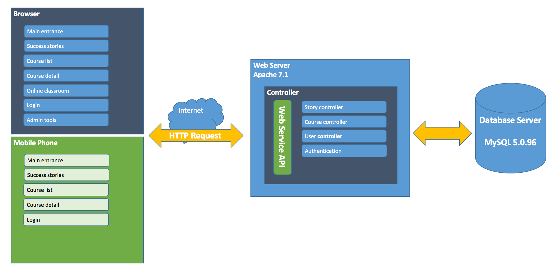

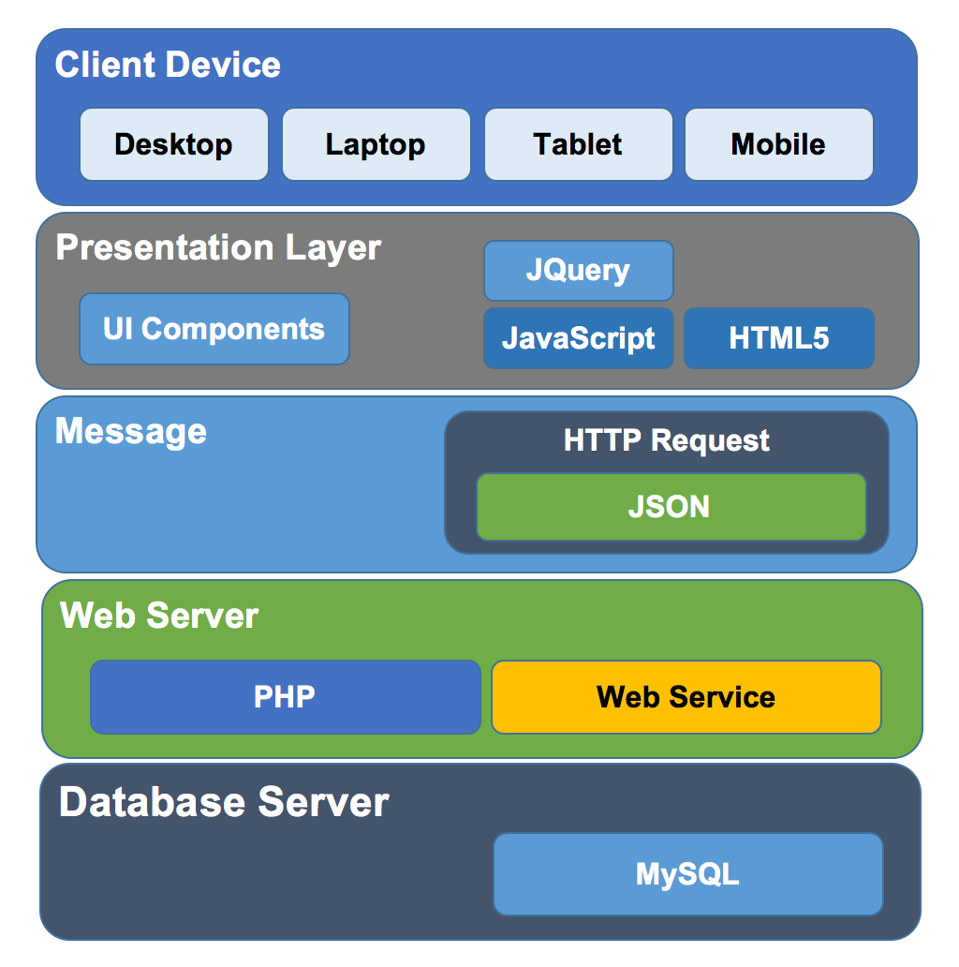

## Class Diagram

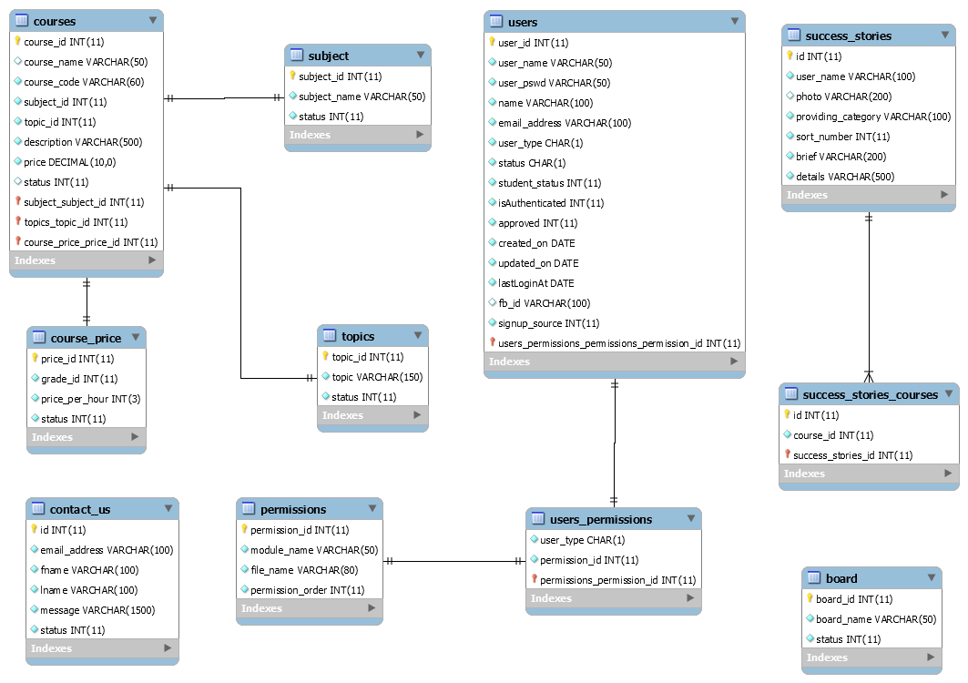

# Design Decisions

|  |  |
| --- | --- |
|  |  |
| Mobile-friendly | Currently, the GetSkills.co.nz website is un-mobile-friendly. Starting April 21, 2015, Google Search will be expanding its use of mobile-friendliness as a ranking signal. (as cited form <https://support.google.com/adsense/answer/6196932?hl>) Since Google’s polity will affect the ranking of the mobile searches results in all languages worldwide, following customer requirements, the new website need to be highly mobile friendly.  We’ve tested the current GetSkills.co.nz website through “Google mobile-friendly test tool”, results shows below:  1) Links too close together  2) Text too small to read  3) Mobile viewport not set  4) Content wider than screen  We expect the refined website can pass all criteria in Google’s Mobile-friendly test tool. |
| Security | Getskills.co.nz website is an online education/employing training website. It contains confidential business information from both their business partners and individual trainees. In this way, the website needs to be strictly security and private. |
| Maintainability | Getskills.co.nz website contains four modules – students, employer company, teachers and administrator. Their website should be able to renew information from different parties, such as new classes, new positions, and new promotions. The website should be maintainable. We decide the maintainable attributes in refined Getskills.co.nz websites will keep pace with the exist website. |
| Aesthetic property | The CEO is not satisfied with page layout designs of the current website. He has a higher expectation on the website layout designs. He want it to be more attractive. He emphases that, “industry need artists and designers to help connect our business with end customers and establish a trust in the brand.” Our team decide to re-beautify the current web pages. We will try to improve the current website page designs to make it more appealing. Relevant techniques involve: CSS, JavaScript. |

# Low Fi Prototypes



## Web Page Workflow

Visitor page workflow



Administrator page workflow



## Main Page

Desktop version



Mobile version



## Successful Stories Module

**List view desktop version**



**Detail view desktop version**



**List view mobile version**

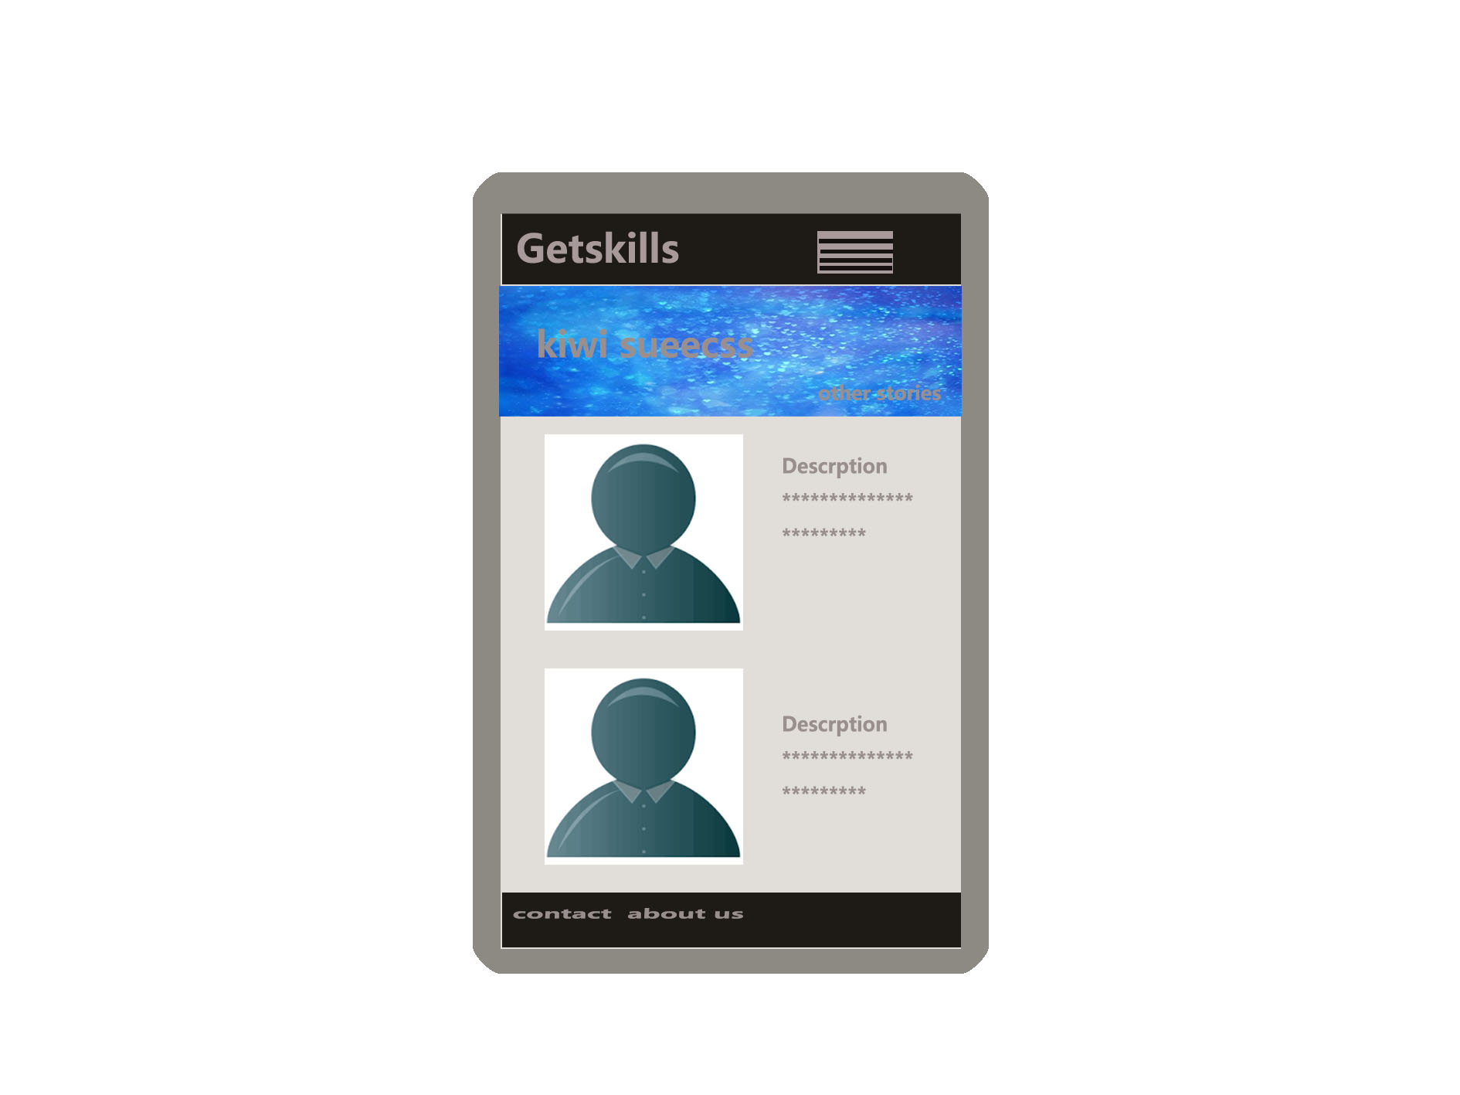

**Detail view mobile version**

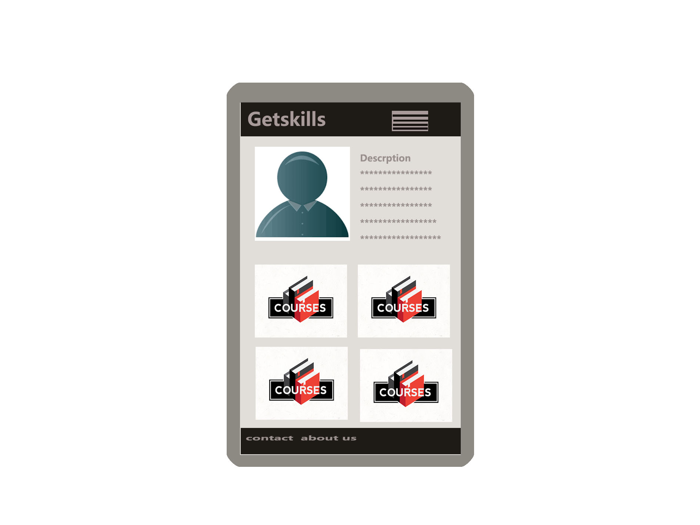

## Administration Tool

(Admin) Courses

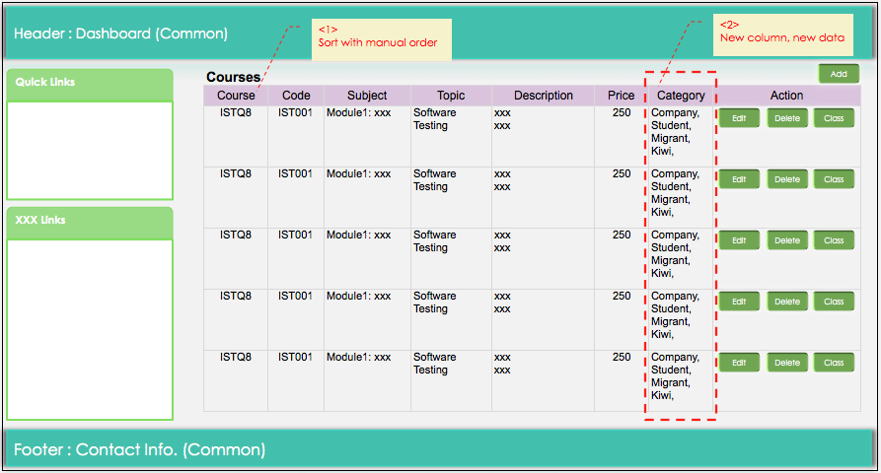

(Admin) Add Course

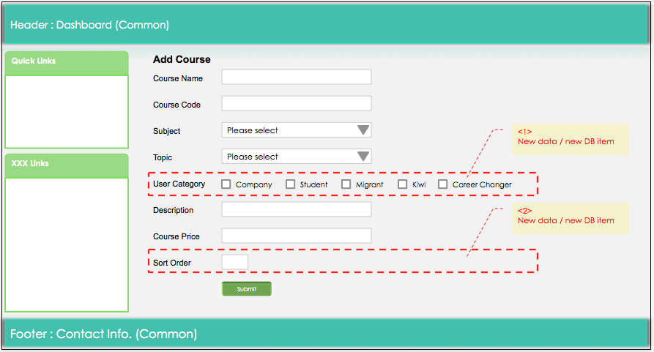

(Admin) Edit Course

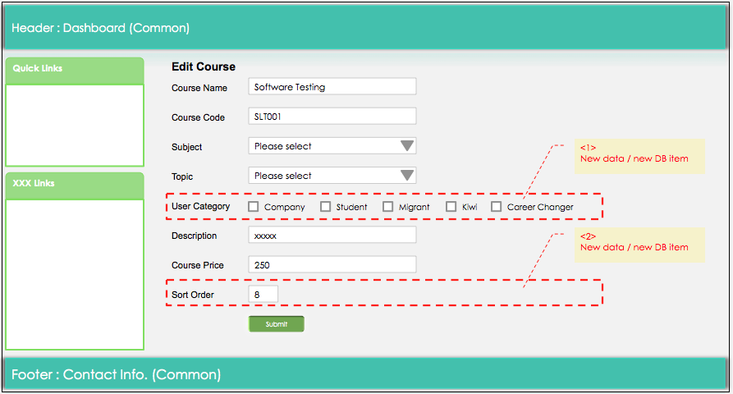

(Admin) Success Stories

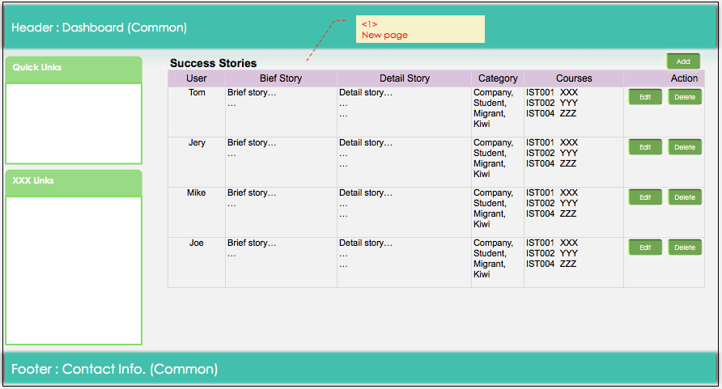

(Admin) Add Success Story

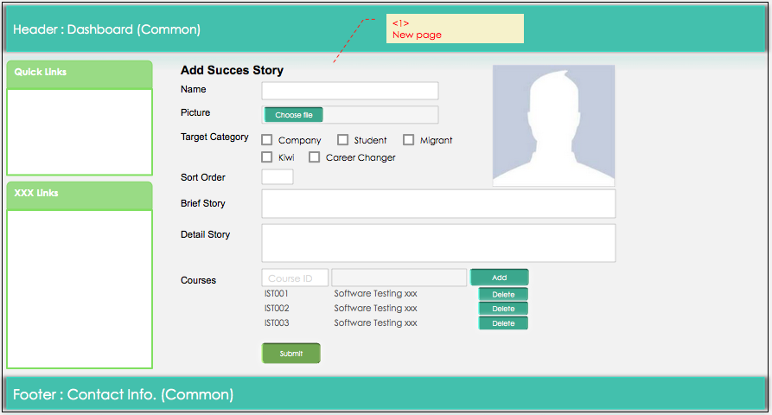

(Admin) Edit Success Story

